Genetic Algo:

Most often one is looking for the best solution in a specific subset of solutions.

This subset is called the **search space** (or state space). Every point in the search space is a possible solution. Therefore every point has a **fitness** value, depending on the problem definition.

GAs are used to search the search space for the best solution, e.g. a minimum.

Difficulties are the local minima and the starting point of the search.

Outline of the basic algorithm

**0 START** : Create random population of n chromosomes

**1 FITNESS** : Evaluate fitness f(x) of each chromosome in the population

**2 NEW POPULATION**

**1 REPRODUCTION/SELECTION** : Based on f(x)

**2 CROSS OVER** : Cross-over chromosomes

**3 MUTATION** : Mutate chromosomes

**3 REPLACE :** Replace old with new population: the new generation

**4 TEST** : Test problem criterium

**5 LOOP** : Continue step 1 – 4 untill criterium is satisfied

**Genetic** **Algorithm – Reproduction Cycle**

1. Select parents for the mating pool

(size of mating pool = population size).

1. Shuffle the mating pool.
2. For each consecutive pair apply crossover.
3. For each offspring apply mutation (bit-flip independently for each bit).
4. Replace the whole population with the resulting offspring.

Crossover (Recombination):

Purpose: Crossover mixes the genes of two parent solutions to create new offspring.

Process: It takes parts from each parent and combines them to form one or more children.

Example: In a genetic algorithm for optimizing routes, it merges parts of two good routes to create a potentially better one.

Mutation:

Purpose: Mutation introduces random changes to solutions to keep things fresh.

Process: It tweaks a random element in a solution, adding a bit of randomness.

Example: In a genetic algorithm for scheduling, it might randomly swap two tasks to see if it leads to a better plan.

**ARTIFICIAL NEURAL NET**

X2

X1

W2

W1

Y

* Information-processing system.
* Neurons process information.
* The signals are transmitted by means of connection links.
* The links possess an associated weight.
* The output signal is obtained by applying activations to the net input.
* The figure shows a simple artificial neural net with two input neurons (X1, X2) and one output neuron (Y). The interconnected weights are given by W1 and W2.

**PROCESSING OF AN ARTIFICIAL NET**

The neuron is the basic information processing unit of a NN. It consists of:

1. A set of links, describing the neuron inputs, with weights W1, W2, …, Wm.
2. An adder function (linear combiner) for computing the weighted sum of the inputs (real numbers)
3. Activation function for limiting the amplitude of the neuron output.

**OPERATION OF A NEURAL NET**

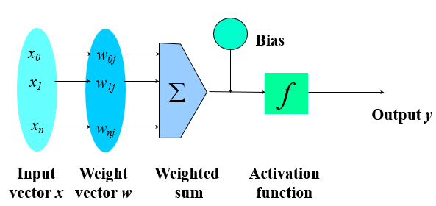

**ARCITECTURE:**

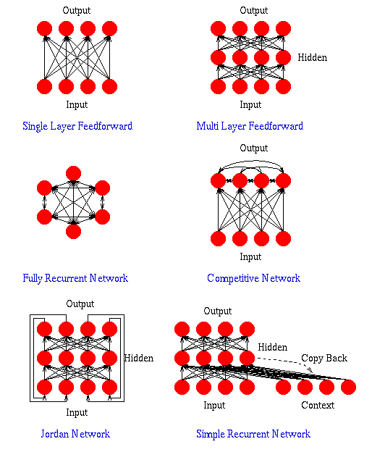

**Supervised Training** - Providing the network with a series of sample inputs and comparing the output with the expected responses.

McCULLOCH–PITTS NEURON: First formal synthetic neuron model based on the highly simplified biological neuron

The inputs are 0 or 1

Outputs o is defined as

Though simplistic the model has sufficient computing potential

It can perform the basic logic operations NOT, OR, and AND, provided its weights and thresholds are appropriately selected

LEARNING AGENT:

10/18/2023

* Though simplistic the model has sufficient computing potential
* It can perform the basic logic operations NOT, OR, and AND, provided its weights and thresholds are appropriately selected